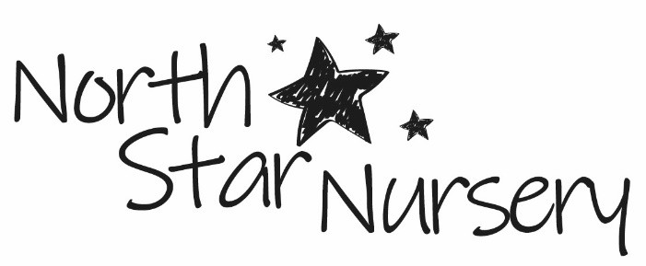

North Star Nursery
Mission Statement

North Star Nursery aims to provide high quality, inclusive childcare and education for children aged between three months and five years, in a suitable and safe environment.
We maintain these aims through our policies, procedures and Continued Professional Development of staff.

Through a language rich environment (both inside and outdoors) we support the holistic development of each and every child to be school ready and reach their potential as individuals.

The Nursery’s onsite service is primarily for the children of the employees of UKRI, UK Shared Business Services (UK SBS) and Innovate UK on a full day care basis in loco parentis.

In addition, North Star Nursery aims to provide a range of on demand services in the early years sector, via student placements, school links and consultancy.

Ofsted registered: 109123

